

Foundations of Programming
Assignment No. : 10

PROBLEM STATEMENT:
Write a program in C to simulate a simple calculator that performs basic arithmetic operations such as addition, subtraction, multiplication, and division. The calculator should also perform special operations like computing xʸ (power) and x! (factorial).

OBJECTIVE:
• To understand the use of switch-case statements in C.
• To perform basic arithmetic and special mathematical operations.
• To enhance problem-solving skills using menu-driven programs.

THEORY:
A calculator is a basic computing device used to perform arithmetic operations. In C programming, a simple calculator can be implemented using conditional or switch-case statements. Arithmetic operations like addition, subtraction, multiplication, and division are fundamental operations. Special operations such as power (xʸ) and factorial (x!) require loops for repeated calculations.

PLATFORM:
Linux

ALGORITHM:

C PROGRAM:
#include <stdio.h>
#include <math.h>

int main() {
int choice;
double num1, num2, result;
int i, n;
long long fact = 1;

printf("Simple Calculator\n");
printf("1. Addition\n");
printf("2. Subtraction\n");
printf("3. Multiplication\n");
printf("4. Division\n");
printf("5. Factorial (x!)\n");
printf("6. Power (x^y)\n");

printf("Enter your choice: ");
scanf("%d", &choice);

switch(choice) {

case 1:
printf("Enter two numbers: ");
scanf("%lf %lf", &num1, &num2);
result = num1 + num2;
printf("Result = %.2lf\n", result);
break;

case 2:
printf("Enter two numbers: ");
scanf("%lf %lf", &num1, &num2);
result = num1 - num2;
printf("Result = %.2lf\n", result);
break;

case 3:
printf("Enter two numbers: ");
scanf("%lf %lf", &num1, &num2);
result = num1 * num2;
printf("Result = %.2lf\n", result);
break;

case 4:
printf("Enter two numbers: ");
scanf("%lf %lf", &num1, &num2);
if(num2 != 0)
printf("Result = %.2lf\n", num1 / num2);
else
printf("Division by zero not allowed\n");
break;

case 5:
printf("Enter a number: ");
scanf("%d", &n);

if(n < 0) {
printf("Factorial not defined for negative numbers\n");
} else {
for(i = 1; i <= n; i++)
fact *= i;

printf("Factorial = %lld\n", fact);
}
break;

case 6:
printf("Enter base and exponent: ");
scanf("%lf %lf", &num1, &num2);
result = pow(num1, num2);
printf("Result = %.2lf\n", result);
break;

default:
printf("Invalid choice\n");
}
return 0;
}

INPUT:
User selects an operation from the menu and enters required values.
Example Input:
Choice: 1
Numbers: 10 20
Screen Shot of Input

OUTPUT:
Example Output:
Result = 30.00
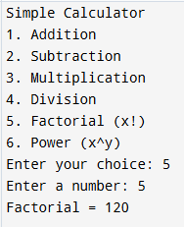
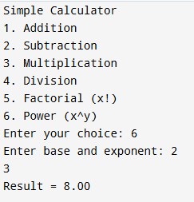
Screen Shot of Output

CONCLUSION:
Thus, a simple calculator program was successfully implemented using C programming. The program demonstrates the use of switch-case statements, loops, and arithmetic operations.

FAQs:
- What is a simple calculator program?
- Why is switch–case preferred in calculator programs?
- How does the program handle division by zero?
- How is the power operation (xʸ) implemented without using math library functions?
- What is factorial and how is it calculated using loops in C?

